S - Tanay Patel

P- Yuri Subramaniam

Q - William Wu

F - Tanav Kambhampati

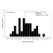***Evolution in Action: Data Analysis* INTRODUCTION**

Activity

Student Handout (Version 1)

How and why do species change over time? In this activity, you’ll explore real data that scientists collected to investigate this question. These data were taken from a population of birds called **finches**, before and after a drought in the Galápagos Islands.

In Part 1, you’ll watch a short film to learn more about the finches and the scientists who studied them: Peter and Rosemary Grant. In Part 2, you’ll interpret the Grants’ data and suggest hypotheses to explain their observations. In Part 3, you’ll explore the reason why the Grants collected data on so many birds. Finally, in Part 4, you’ll use the data to make graphs and propose how and why some characteristics are more likely than others to change from one generation to the next. The concepts you’ll learn apply not only to finches in the Galápagos but also to any organism in any environment.

**MATERIALS**

• the finch data set (in *Data Explorer* or as a spreadsheet)

• access to *Data Explorer* or a spreadsheet program

• (optional) calculator and graphing materials (colored pencils, rulers, graph paper, etc.)

**PART 1: Introducing the Study**

In 1973, biologists Peter and Rosemary Grant began observing finches 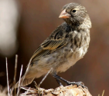

on several islands in the Galápagos. They wanted to understand how

changes in the environment can influence a species’ physical

characteristics.

As part of their work, the Grants studied the population of medium

ground finches (Figure 1) on the island of Daphne Major. Every year for

40 years, the Grants measured several physical characteristics —

including wing length, body mass, and beak depth — of hundreds of

medium ground finches. They focused on these characteristics because they vary widely among individual birds within the same species. Small differences in these characteristics can also be important for survival in different environments.

**Figure 1.** A medium ground finch (*Geospiza fortis*), one of the finch species on Daphne Major. 

Watch the short film *The Beak of the Finch* to learn more about the Grants’ research and some of their findings. Answer the following questions based on what you learned.

1. Describe the major environmental change on Daphne Major that took place in 1977.

There was a major drought that took place on Daphne Major in 1977. This drought made it harder for animals to get food, since the drought wiped out most of the vegetation. There were only cacti and big trees left; no more small flowers that the smaller beaked finches depended on. It turned the islands very dry and created competition for species scavenging for scarce food.

2. What types of medium ground finches were *more* likely to survive the environmental change you described?

The finches that were more likely to survive were the ones with larger beaks. This allowed them to eat more different types of seeds. The finches were forced to eat bigger seeds that required larger beaks to eat, so most finches with smaller beaks died causing the next generation to have larger beaks than the previous generation.

**www.BioInteractive.org** Updated April 2021 Page 1 of 6

***Evolution in Action: Data Analysis***

**Activity**

**Student Handout V1**

**PART 2: Analyzing Data with Histograms**

You will now explore one of the Grants’ data sets. Open the finch data set. In *Data Explorer*, you can do this by clicking “Choose data to explore” on the landing page, selecting the “Finches in the Galápagos” data set, and then clicking the **“Data”** tab at the top.

This data set contains measurements from 100 medium ground finches on Daphne Major, all born between 1973 and 1976. The 50 finches labeled as nonsurvivors did not survive 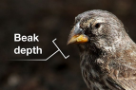

the drought and died in 1977. The 50 finches labeled as survivors

survived the drought and were still alive in 1978.

While exploring the data set, you may notice some differences between

the nonsurvivors and survivors. These differences may have involved

**beak depth**, which is a measure of beak size (Figure 2).

One way to visualize the differences is to graph the data. Figure 3 shows graphs of beak depth measurements for the nonsurvivors and

**Figure 2.** A diagram showing how beak depth is measured.

survivors. These types of graphs, called **histograms**, show the distribution of measurements — that is, the values that were measured and how often they occurred.

**Figure 3.** Histograms showing the beak 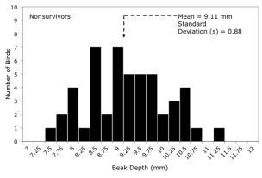

depths, measured in millimeters (mm),

of 100 medium ground finches from

Daphne Major.

The top graph shows the beak depths

of the nonsurvivors (50 birds that did 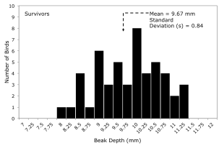

not survive the drought of 1977).

The bottom graph shows the beak

depths of the survivors (50 birds that

survived the drought and were still

alive in 1978).

**www.BioInteractive.org** Updated April 2021 Page 2 of 6

***Evolution in Action: Data Analysis*** 

Use Figure 3 to answer the following questions.

**Activity**

**Student Handout V1**

3. Observe the shapes of the graphs. It may help to draw a line connecting the tops of the black bars. a. Describe the overall shape of each graph.

The top graph is single peaked and also barely skewed to the right. It also has one outlier at the beak depth of 11.25mm. The data is also quite spread out

The bottom graph is also single peaked and skewed to the left.

b. What do the shapes of the graphs indicate about the distribution of beak depths in these two groups of birds? In the histogram it indicates that the number of finches with larger beaks were the ones more likely to survive the drought. The smaller beaked finches had a tougher time surviving.

4. Compare and contrast the distributions of beak depths for the survivors and nonsurvivors. For each distribution, include the range of the data and the most common measurements.

The average beak depths of the nonsurvivors was 9.11 mm and it was 9.67 mm for the survivors. The most common measurements were around 8.5 and 9 for the nonsurvivors and 10 for the survivors. The range for the survivors was 4 mm and the range of the nonsurvivors 3.5 mm.

5. Propose a biological hypothesis to explain the differences in the distribution of beak depths for the survivors and nonsurvivors. (*Hint*: It may help to review your answers for Part 1.)

The beak depths of finches who survived the drought are on average larger than those who died because of the lack of accessibility to food for the small beaked finches.

Each graph also lists the **mean** (average) beak depth for that group of birds, as well as the **standard deviation** (*s*) for beak depth in that group. Standard deviation indicates the amount of variation in a set of measurements — in other words, how spread out the measurements are. A *larger* standard deviation means that the measurements are *more* spread out.

In each of these groups, most of the measurements fall within one standard deviation from the mean. The beak depths of the nonsurvivors, for example, have a mean of 9.11 mm and a standard deviation of 0.88 mm. Most of the birds in this group have beak depths that are between 8.23 mm (one standard deviation below the mean) and 9.99 mm (one standard deviation above the mean).

6. Take a look at the means and standard deviations of beak depth in each group.

a. How do these means and standard deviations compare between the groups?

The survivors have a larger mean beak depth. For both groups, The standard deviation indicates that the data is pretty spread apart and nowhere close to the mean.

b. If the standard deviations of the two groups were very different, what would you conclude about the groups?

I would conclude that one group had much more variability than the other. For example, if the Nonsurvivors had a much higher standard deviation, I would conclude that there was much more variability in beak sizes of nonsurvivors, and that only a very small selection of beak sizes were survivors.

**PART 3: Examining the Importance of Sample Size**

The Grants measured beak depths of hundreds of birds every year, and this extraordinary effort was critical to their discoveries. But why was it important to collect data on so many birds?

Let’s see what could have happened if they’d had data from far *fewer* birds. Table 1 below shows data from much smaller samples (5 or 15 birds), which were randomly selected from the larger data set you saw earlier (which had 50 nonsurvivors and 50 survivors).

**www.BioInteractive.org** Updated April 2021 Page 3 of 6

***Evolution in Action: Data Analysis***

**Table 1.** Beak depths (mm) in random samples of nonsurvivors and survivors.

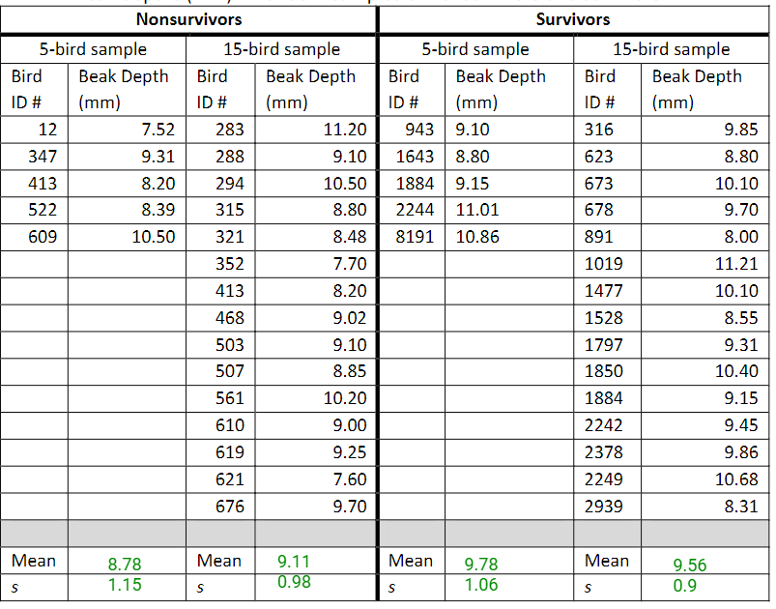

**Activity**

**Student Handout V1**

The mean and standard deviation of each sample have been left blank for you to calculate in the questions below. You can calculate them using a calculator or spreadsheet program. To calculate the standard deviation of the sample (*s*), you can use the equation and steps below:

���� = �∑(�������� − ~~����~~)2

(���� − 1)

• Calculate the mean (~~����~~) of the sample.

• For each measurement (����i) in the sample, determine the difference between that measurement and the mean. This will be (����i − ~~����~~).

• Square the difference you got in the previous step. This will be (����i − ~~����~~)2.

• Add up all of the squared differences to get Σ(����i − ~~����~~)2. The symbol Σ represents summation, or adding together.

• Divide your result by the number of birds in the sample (*n*) minus 1.

• Take the square root of your result.

7. For each sample, calculate the mean beak depth and standard deviation (*s*). Record your answers in Table 1.

8. Record the means and standard deviations for each sample of survivors and nonsurvivors (the 50-bird samples in Figure 3, then the 15-bird and 5-bird samples in Table 1) in Table 2.

Survivors Nonsurvivors

5 Bird Sample: Mean: 9.78 s: 1.06 5 Bird Sample: Mean: 8.78 s: 1.15

15 Bird Sample: Mean: 9.56 s: 0.9 15 Bird Sample: Mean: 9.11 s: 0.98

**www.BioInteractive.org** Updated April 2021 Page 4 of 6

***Evolution in Action: Data Analysis***

**Activity**

**Student Handout V1**

**Table 2.** Means and standard deviations of beak depths (mm) in different samples of nonsurvivors and survivors.

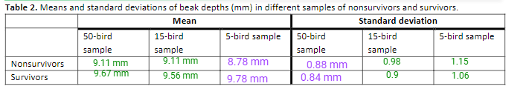

9. Compare the means and standard deviations for the samples in Table 2.

a. Are the means in smaller samples different from the means in larger samples? Explain why you think that is. Yes, some of the smaller sample mean calculations are smaller compared to the larger samples. I think that outliers in these samples can skew the data. If there is a larger sample the majority of the data will overrule the outliers.

b. Are the standard deviations in smaller samples different from the standard deviations in larger samples? Explain why you think that is. Yes, they are different, the smaller samples are different to the larger samples for SD. I feel that outliers play a massive role in this.

10. Which results (from 5, 15, or 50 birds) do you think are *closest* to the means and standard deviations of the entire population of medium ground finches on the island? Explain your answer.

I think the results of 50 birds will have the closest mean and standard deviation to the entire population of medium ground finches on the island. This is because the 50 birds has the largest sample size, giving the closest results to the entire population on the island.

11. What is one advantage and one disadvantage of calculating the mean from a sample of a population rather than the entire population?

An advantage is that calculating the mean from a sample is far more doable than calculating the mean for the entire population and a disadvantage is that it isn’t as accurate.

**PART 4: Adaptive Traits and Constructing Bar Graphs**

In addition to beak depth, Peter and Rosemary Grant collected measurements for dozens of other finch traits, such as wing length and body mass. Table 3 summarizes the means of body mass and wing length for samples of nonsurvivors and survivors.

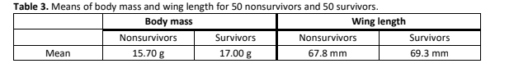

Let’s compare the means of these traits in the two groups using graphs. A **bar graph** is often a good choice for comparing a single numerical value among different groups.

12. Construct two bar graphs, one comparing the means of *wing length* for the two groups and another comparing the means of *body mass*.

• You can draw the graphs by hand below, or you can make them on a computer using *Data Explorer* (under the **“Visualize”** tab at the top) or another program. Make sure to include all your graphs when submitting this handout.

• For each graph, make sure to include a title and labels for the axes (including units).

Graphs made by purple

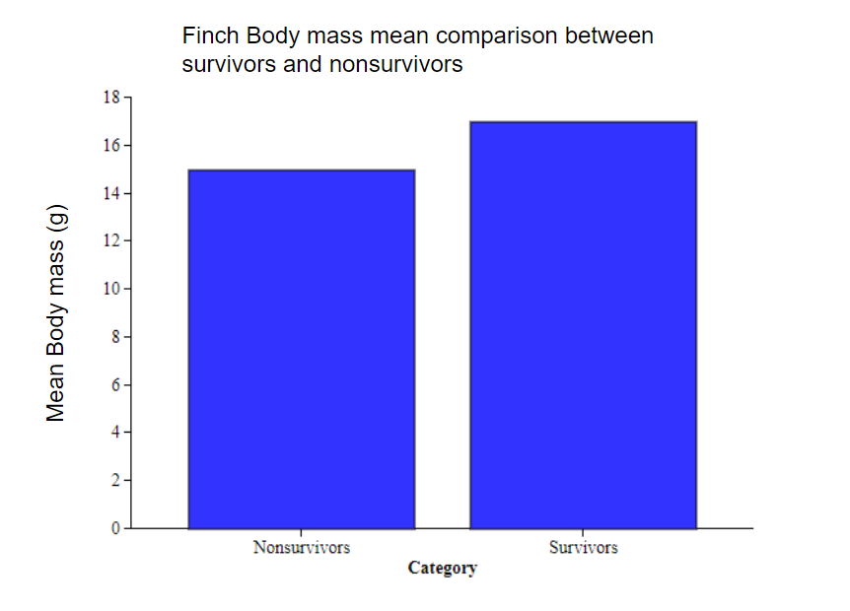

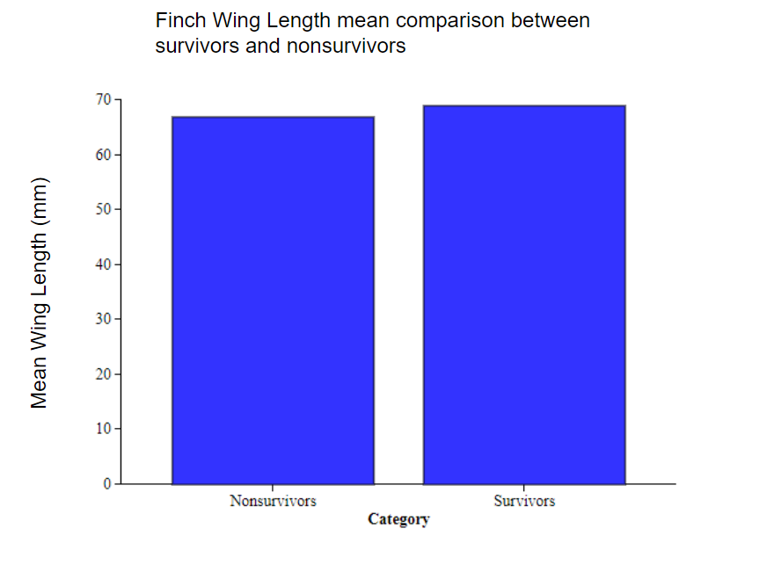

**www.BioInteractive.org** Updated April 2021 Page 5 of 6

***Evolution in Action: Data Analysis***

**Activity**

**Student Handout V1**

13. Based on your graphs, how does the mean wing length compare between survivors and nonsurvivors? What about the mean body mass?

The mean wing length is higher in survivors than nonsurvivors. The mean body mass is also higher in the survivors. However, the differences are not that drastic, the means are pretty close in nonsurvivors and survivors.

14. What do your graphs suggest about the effects of the drought on birds with particular wing lengths and body masses? The graph suggests that the greater the body mass/wing length, the more likely the finch was to survive during the drought.

15. The film in Part 1 claimed that beak depth is the trait that made the greatest difference in survival for the birds during the drought. Do the data you examined support this claim? Explain your answer

The data shows that wing length and body mass made a difference, but the beak depth made the greatest difference. The data shows that wing length and body mass were relatively similar, but beak depth was the factor that made the greatest difference.

16. Based on what you learned from the film, why might beak depth play a more important role in survival during the drought than either wing length or body mass? (*Hint:* According to the film, what was the main impact of the drought on the finches?) During the drought the main impact was the lack of vegetation, resulting in many finches dying. Beak depth might have played an important role in survival for the reason being that they had to compete for food. In the film the only food they could consume were these spikey brittle seeds, meaning the finches needed a bigger beak depth to consume them.

17. How might variation in key traits within a population, such as beak depth in medium ground finches, make that population more likely to survive environmental changes?

Variation in traits within a population makes that population more likely to survive since natural selection wipes out the finches that are at a disadvantage to environmental change. This leads the “better” finches to survive and create offspring with the better traits. In medium ground finches, the beak depth was a key trait which put many finches at a disadvantage based on the environmental change. In a drought, species with larger beak sizes survived and these produced offspring that had these traits, making the population more likely to survive environmental change.

**SHO2 Activity 2**

**PART 2: Calculating Descriptive Statistics**

You will now calculate descriptive statistics for physical characteristics in this sample of finches. **Descriptive statistics** are numbers that summarize the features of the data and their distribution. Table 1 lists five types of descriptive statistics: mean, variance, standard deviation, standard error of the mean, and 95% confidence interval. As you’ll see by doing the calculations below, these statistics are related to each other and can reveal information not only about the sample, but also the entire population from which the sample was taken.

Follow the steps below the table to complete the calculations. You can do the calculations by hand, in *Data Explorer* (under the **“Analyze”** tab at the top), or with another program. Make sure to record each calculation in Table 1. The variance calculations are filled in for you as an example.

**www.BioInteractive.org** Updated April 2021 Page 2 of 6

***Evolution in Action: Data Analysis ***

**Activity**

**Student Handout V2**



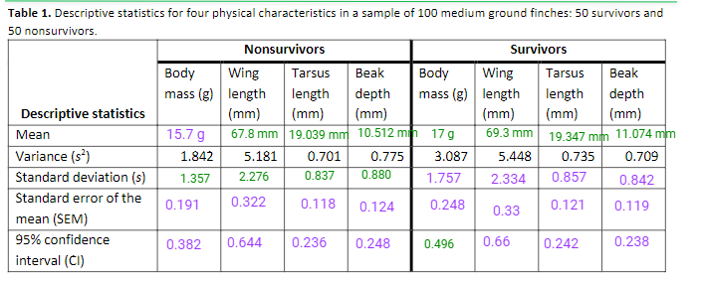

The first descriptive statistic for you to calculate is the **mean**, or average, of the sample.

3. Calculate the mean for each column in Table 1, and record your results (rounded to two decimal places) in the table.

The next descriptive statistic to calculate is the sample **standard deviation** (*s*), which measures the mean difference between each individual measurement and the mean of the sample. Standard deviation is a way to quantify how spread out a set of measurements is compared to the mean.

The sample standard deviation is the square root of the sample variance (*s*2). You can use the variances shown in Table 2 to calculate the standard deviations.

4. Calculate the standard deviation for each column in Table 1, and record your results (rounded to two decimal places) in the table.

The next descriptive statistic to calculate is the **standard error of the mean (SEM)**. The SEM is the standard deviation of the means of multiple random samples taken from the same population. About 68% of the sample means are within one SEM of the population mean.

As a result, the SEM can be used to measure how well the mean of any random *sample* estimates the mean of the entire *population*. You can use the formula below to estimate the SEM:

SEM = ����√����

5. Calculate the standard error of the mean for each column in Table 1, and record your results (rounded to two decimal places) in the table.

The last descriptive statistic to calculate is the **95% confidence interval (CI)**. The 95% CI provides a range around the *sample* mean within which the mean of the *entire population* is likely to be found. (Specifically, there is a 95% chance that the 95% CI contains the mean of the entire population.) You can approximate the 95% CI as twice the SEM.

6. Calculate the 95% CI for each column in Table 1, and record your results (rounded to two decimal places) in the table.

**PART 3: Graphing the Data**

Let’s compare the means you calculated for the two groups using graphs. A bar graph is often a good choice for comparing a single numerical value among different groups.

**www.BioInteractive.org** Updated April 2021 Page 3 of 6

***Evolution in Action: Data Analysis ***

**Activity**

**Student Handout V2**

****Look at the following example of a well-constructed bar graph. Note that it contains a title, labels for the axes (including units), and an explanation for what the error bars represent.

**Mean dorsal fin height among male and female orcas**

**)**

**m**

**(**

**t**

**h**

**g**

**ie**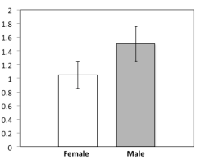

**h**

**n**

**i**

**f**

**l**

**a**

**s**

**r**

**o**

**d**

**n**

**a**

**e**

**M**

Mean dorsal fin height in meters (m) for 36 female and 36 male orcas (*Orcinus orca*). In this case, error bars represent 95% CIs.

7. Construct four bar graphs that compare the means of each physical characteristic (body mass, wing length, tarsus length, and beak depth) for survivors and nonsurvivors.

• You can draw the graphs by hand on a separate sheet of graph paper, or you can make them on a computer using *Data Explorer* (under the **“Visualize”** tab at the top) or another program. Make sure to include all your graphs when submitting this handout.

• For each graph, make sure to include a title, labels for the axes (including units), and error bars that represent 95% CIs.

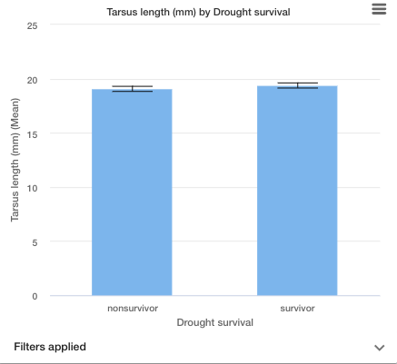

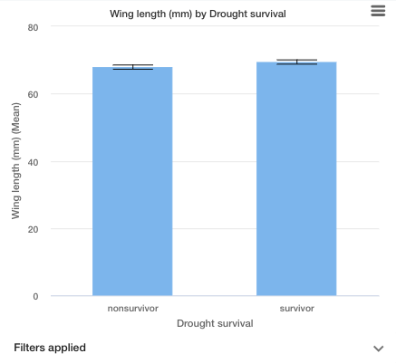

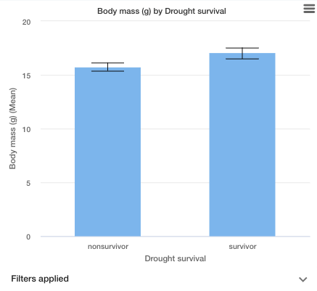

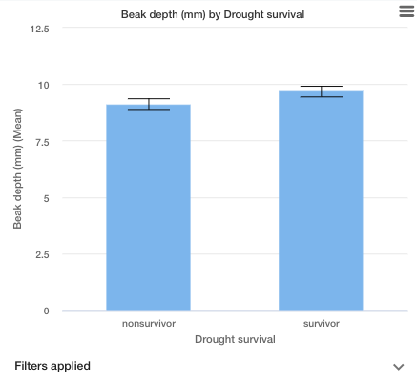

8. In some cases, whether or not your error bars overlap can suggest whether the difference between the means is **statistically significant** — that is, due to actual differences between nonsurvivors and survivors instead of just happening by chance.

a. You created error bars that represent 95% CIs. What does it suggest if these error bars do *not* overlap? What does it suggest if these error bars *do* overlap?

If the error bars do overlap, it means that there is not much of a difference between the survivors and nonsurvivors. If the bars don’t overlap, that means that there is a significant difference between the survivors and nonsurvivors. For example, if the error bar for the tarsus lengths didn’t overlap, that would mean that there was no significant advantage to having a larger tarsus.

b. For which of the four physical characteristics did your error bars *not* overlap

For beak depth, wing length and body mass, the bars do not overlap.

9. Summarize the differences between nonsurvivors and survivors that you observed from your graphs. Make sure to consider each of the four physical characteristics and the error bars from the previous question.

The difference between survivors and nonsurvivors of the drought is that the survivors were overall bigger. Beak depth, tarsus length, body mass, and wing length were all bigger in the survivors. In the graphs for beak depth, wing length, and body mass, the error bars didn’t overlap, meaning that there was a significant difference in those values.